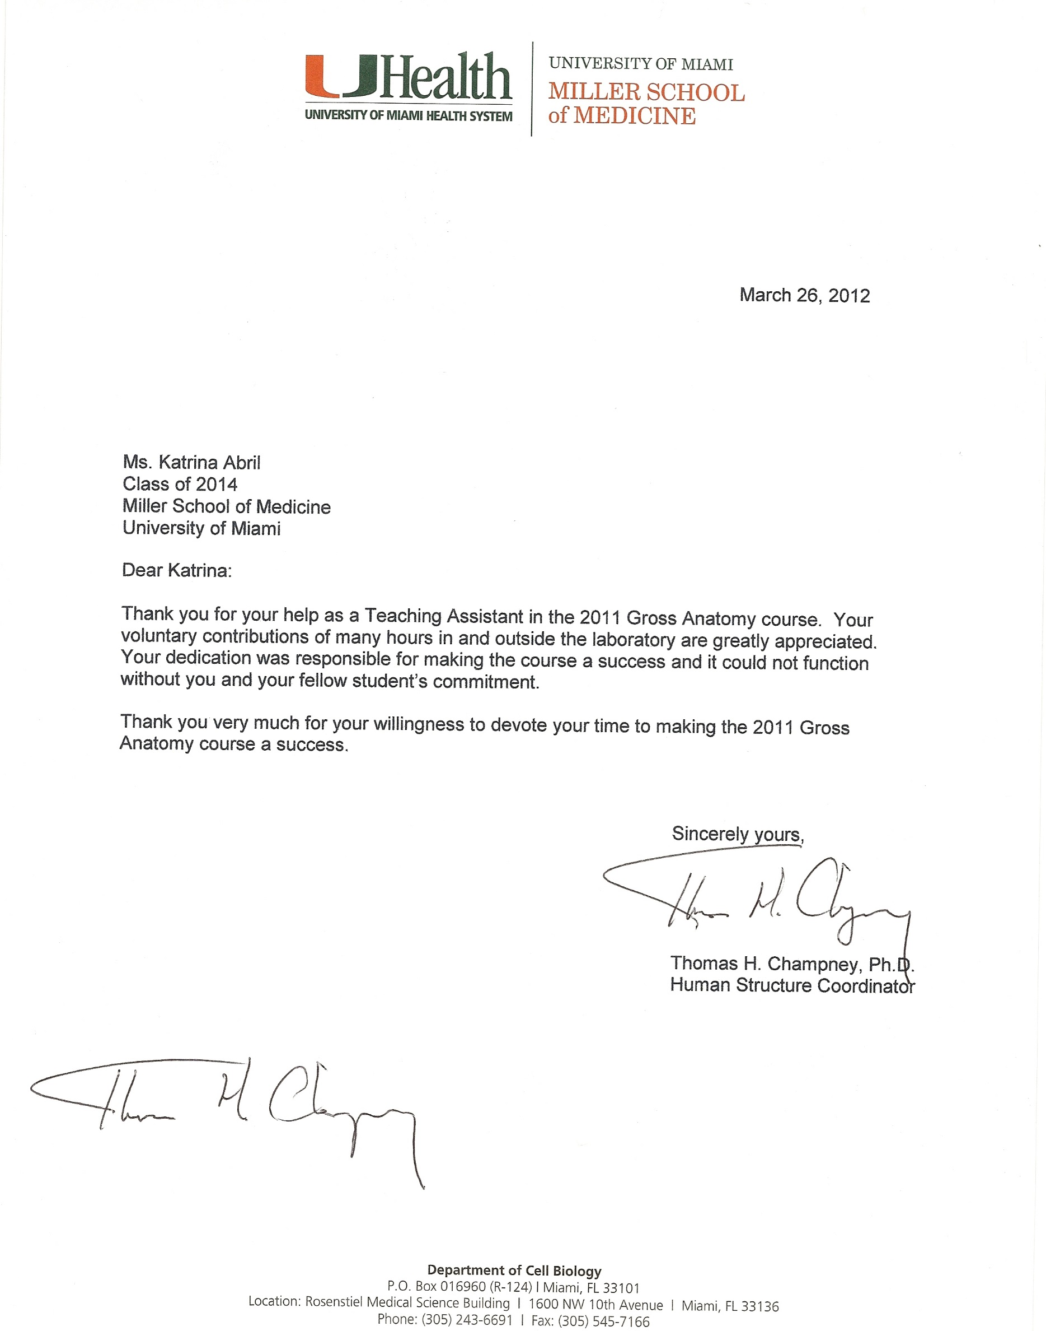

**SUPPLEMENTAL INFORMATION**

The students who will be learning from your donation would like to be able to correlate your previous medical history with what they find during their studies. If you would be willing to provide any information on your past medical history, we would use it to help educate future medical professionals. Any information that you provide is **COMPLETELY VOLUNTARY**. You are also welcome to have this information removed from your donor file at any time.

MEDICAL HISTORY:

1) List any long-term medical issues such as diabetes, high blood pressure, etc.

2) List any hospitalization(s) and reason(s).

3) List any surgeries and/or procedures.

4) Have you ever smoked? Yes / No Type: ___ Tabacco ___Vape ___Other

  If yes, how many per day, and for how many years?

5) Have you ever drank alcohol? Yes / No

If yes, how many drinks per week on average, and for how many years?

6) Describe anything else about your lifestyle or personal habits that may be helpful for the students to know such as exercise, diet, etc.

PERSONAL INFORMATION:

If you would like to provide a short biography of your life and/or a photograph that you would like to share with the students, please feel free to add them. We would request that you not use personally identifying information, since we strive to maintain your anonymity with the students. The students do, however, appreciate knowing about your life and your reasons for donating.

Once a year, we hold a memorial service [“Rose Ceremony”] for all those individuals who donated their bodies. If interested in viewing or attending, contact our office for further information.

Thank you for your willingness to donate your body for the education of future medical professionals. Your altruism, self-sacrifice and generosity are greatly appreciated.